Types of analysis recommended for PFR
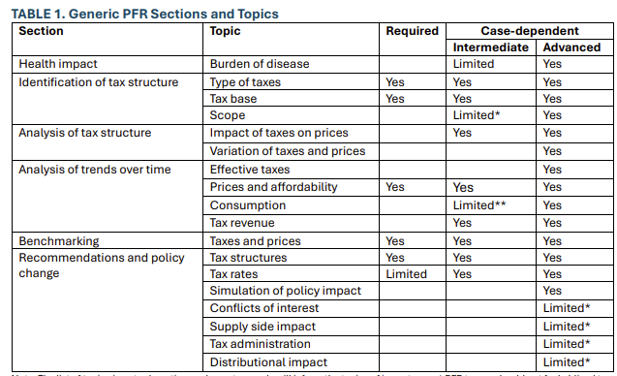

Types of health analysis that could be integrated with climate analysis into a joint offering on excise taxes

Benchmarking

Current consumption levels
- The climate program benchmarks how fuel consumption has evolved in aggregate (Kaya identity) and how it is currently split among households.
- The health program benchmarks how consumption of health-related products has evolved over time, in aggregate.
- The climate program and health program identify the composition by fuel/alcohol subcategory respectively.

Current tax levels
- The climate program calculates the Total Carbon Price for all countries. It expresses across fuel products how a country currently taxes carbon.
- The health program calculates how tobacco, sugar beverages, and alcohol are currently taxed.
- Would it then be possible to have joint assessment that benchmarks how all countries do in excise taxation of goods with externalities?
- Just as countries tax different fuels very differently, they tax different types of alcohol differently. The TCP analysis, that suggests where countries’ excise taxes differ when fuel taxes are expressed in unit of carbon content, has an equivalent in comparisons of excise taxes on different alcoholic beverage that are expressed in unit of alcohol content.
- The health program calculates the share of the price of health-related products that comes from excise taxes. The climate program does not do this for fuels, but has that data.

Tax gaps
- The climate program compares the excise taxes on fuels with the social costs of these fuels.
- The health program cites total costs from tobacco use. Does the health program compare current excises with social costs of health-related products?

Disease levels
- The climate program estimates baseline fatalities and DALYs from air pollution and their link to fuel consumption.
- The health program estimates baseline fatalities and DALYs from the consumption of tobacco and alcohol.

Price evolution
- The health program compares the evolution of prices on health-related products with the evolution of general CPI inflation. The health program also calculates how the price of health-related products has evolved as a percentage of household incomes, as a measure of the affordability and if taxes keep track in providing discouragement.
- The climate program does not do either, but has that data.

Reform analysis

Revenue
- Both the climate program and the health program quantify revenue impacts of tax reforms.

Prices
- Both the climate program and the health program quantify the impact of tax reforms on product prices.

Product use
- The climate program estimates how fuel taxes reduce fuel consumption.
- The health program estimates how health taxes reduce consumption of health-related products.

Disease
- The climate program estimates how fuel taxes reduce fatalities and DALYs from air pollution, and impacts for reducing health care costs.
- The health program estimes

Equity
- The climate program quantifies the equity effects of fuel price changes using household surveys and input-output tables.
- Equity effects of tobacco taxes are simulated by Poverty using the Stata tool TOBACTAX. It has been applied to individual countries, but there seems to not be a body of evidence for 125 countries as for equity analysis of fuel taxes. Poverty has taken strong positions on equity effects of excise taxes, but only seems to be referring to tobacco and a few country studies.
- Could reopen the household surveys used in CPAT to see where the same apparatus could be used to simulate equity effects, including for the revenue use? Perhaps not feasible for SSB as it is not distinguishable in household surveys but for tobacco and alcohol?
- CPAT also considers indirect consumption of fuels that are used as an input to the production of other goods. But no such analysis is needed for health taxes because alcohol, tobacco and sugar-sweetened beverages are not used as inputs to producing other goods. They are only used directly. Also, health taxes are normally levied downstream in the supply chain for alcohol, where it affects end products, rather than upstream where it enters as a factor of production to other goods (ethanol used as fuel, alcohol used for cleaning). So there is no need to harmonize household surveys with IO tables?
- Both programs consider the variation of price elasticities between income groups.
- Norman has worked on equity effects of health taxes.

Macroeconomic effects
- The health program does not currently estimate the output and employment effects of health-related taxes. But revenues are available that would enable fiscal multiplier analysis?

Informality
- The climate program presents the existence of informality as a reason to tax fuels, arguing that, although fuel taxes can be evaded, they are harder to evade than income taxes or VAT.
- The health program presents the existence of illicit trade as a worry for health taxes.
- Both programs could strengthen their case by comparing the vulnerability to illicit/informal markets to the vulnerability of conventional taxes.
- Norman has worked on measuring illicit cigarette trade.

Design

Specific versus ad-valorem
- The programs both advise against the use of ad-valorem taxes for externalities.
- As they advise for specific-rate taxes, both programs propose inflation updating.

Tools
- Need to identify the list of tools available by both teams and show on Excise tax section of website.
- Is a joint PowerBi website feasible?
- Or PFR Visualization Tool input?

